The five kingdoms of the living world
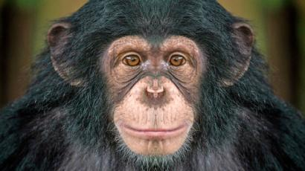
Kingdom Animalia: All organisms in this kingdom are multicellular. Each cell stores its genetic material in a nucleus but doesn’t have a cell wall. Animals gain energy from other living things. We belong in this kingdom. Zoologists are the scientists who study animals.

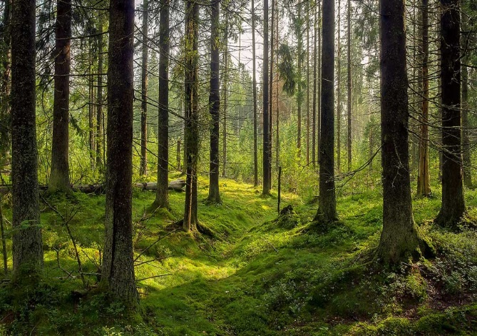
Kingdom Plantae: Plants include tress, vines, bushes, ferns, mosses, weeds and grasses. They all gain energy by making their own food from sunlight. They are multicellular and their cells have a cell wall around the outside of the cell, as well as a nucleus inside the cell. Botanists are the scientists who study the plant kingdom.
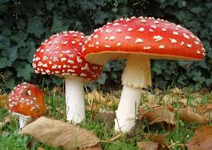
KingdomFungi: Includes mushrooms, toadstools, yeasts, puffballs, modulds and truffles. Some fungi grow in wood and in soil, and develop from tiny spores. Fungi store their genetic material in a nucleus and do not make their own food. Instead , they feed on the remains of dead animals and plants. Some fungi can cause diseases, such as tinea. Mycologists are the scientists who study Kingdom Fungi.
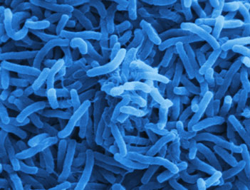
Kingdom Monera: This kingdom is made up of the simplest and smallest living things. There are approximately 75000 different organisms in kingdom Monera and they are all unicellular and have a cell wall but no nucleus. Bacteria are the most common in this kingdom. Many people think of bacteria as harmful to humans, but this is not always true. Bacteria in the soil break down rubbish and waste produced by animals. Without Bacteria, we would be surrounded by mountains of smelly rubbish. Bacteria is also used to produce some foods such as cheese and yogert. Microbiologists are the scientists who study microorganisms in kingdoms Monera and Protista.
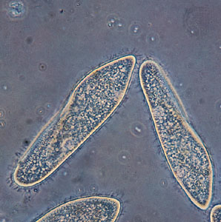
Kingdom Protista: There re approximately 55 000 species of protists. Their cell structure is more complex than that of monera. Often, organisms to much larger ones, like seaweed. They do all have one feature in common: they store their genetic material in a nucleus. Plankton, the tiny sea creatures eaten in their millions by whales, are part of this kingdom. Amoeba, microscopic organisms that change their shape to trap their food, also belong to this group.

Questions

- Name four features that all animals have in common

- Name four features of kingdom fungi

- Name an organism made up of just one cell

- How is a protist different from bacterium?

- What is the difference between cells in kingdom plantea and kingdom fungi?

- Why was the invention of the microscope impotant to our understanding of living things?

